- From the Swapps Menu. Click on Import UNFI
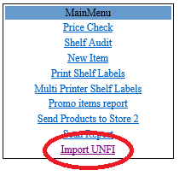

- Click on the “Browse” button to pick a file after which Click on the “View” button to review the file.
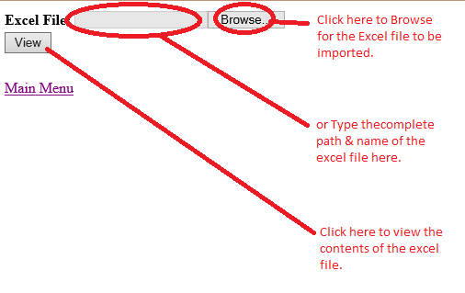

- Pick a sheet
- Pick a department
- Pick a vendor
- Select the appropriate column where :
  - Upc
  - Item Code
  - Desription
  - Pack
  - Size
  - Cost
  - Price
  - Tax
- Select the appropriate starting row. Starting from the first row containing data (not the header).
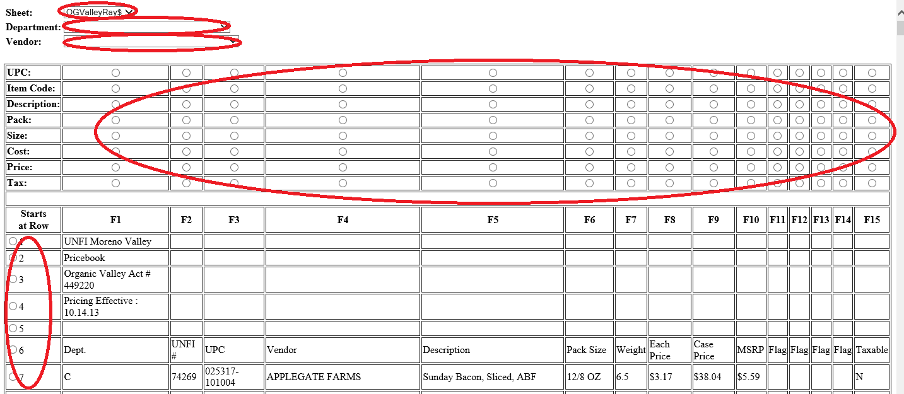

- And Click on “Import” button at the bottom of the page
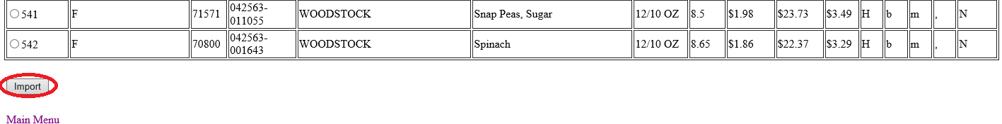

- Scroll to the bottom of the page.

